CODE[CR]

IMPORTING NECESSARY MODULES



DEFINING FUNCTION FOR CRYPT CONFIGURATION

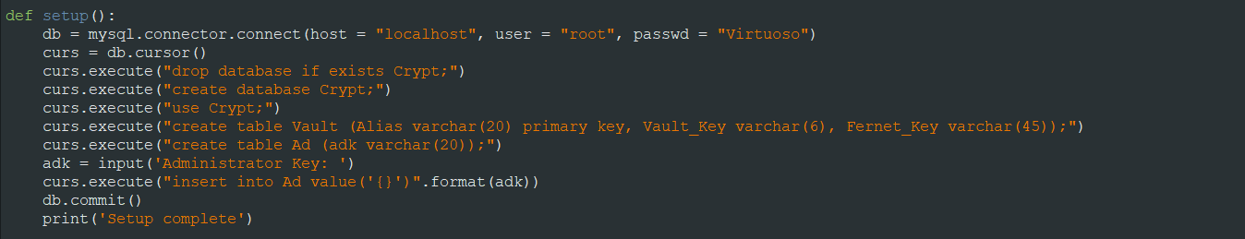

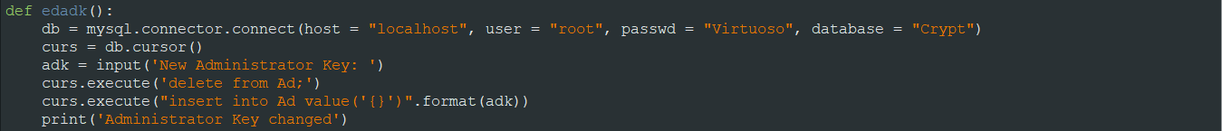

DEFINING FUNCTION FOR PROGRAM EXECUTION

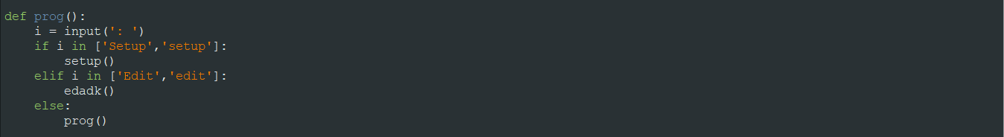

EXECUTING PROGRAM



OUTPUT[CR]

SETUP



ALTER EXISTING ADMIN KEY



KEY [IN CRYPT[DATABASE]]



KEY [EDITED] [IN CRYPT[DATABASE]]

